**How Does Auto-Staking work?** Auto-Staking  
  


* The SAP Auto-Stake feature is a simple yet cutting-edge function called **Buy-Hold-Earn**, that provides the ultimate ease of use for $RGE holders.
* **Buy-Hold-Earn** - By simply buying and holding $RGE token in your wallet, you earn rebase rewards as interest payments directly into your wallet. Your tokens will increase **every 9 minutes**.
* Using a Positive Rebase formula, Ragnarok makes it possible for token distribution to be paid directly proportional to the epoch rebase rewards, worth 0.6142%% every 9 minute epoch period of the total amount of $RGE tokens held in your wallet. The rebase rewards are distributed on each EPOCH (9 minute rebase period) to all $RGE holders.  
    
  **This means that without moving their tokens from their wallet, $RGE holders receive an annual compound interest of 852,103.70% for Year 1.   
    
  The interest rebase rate then reduces after the first 12 months.**

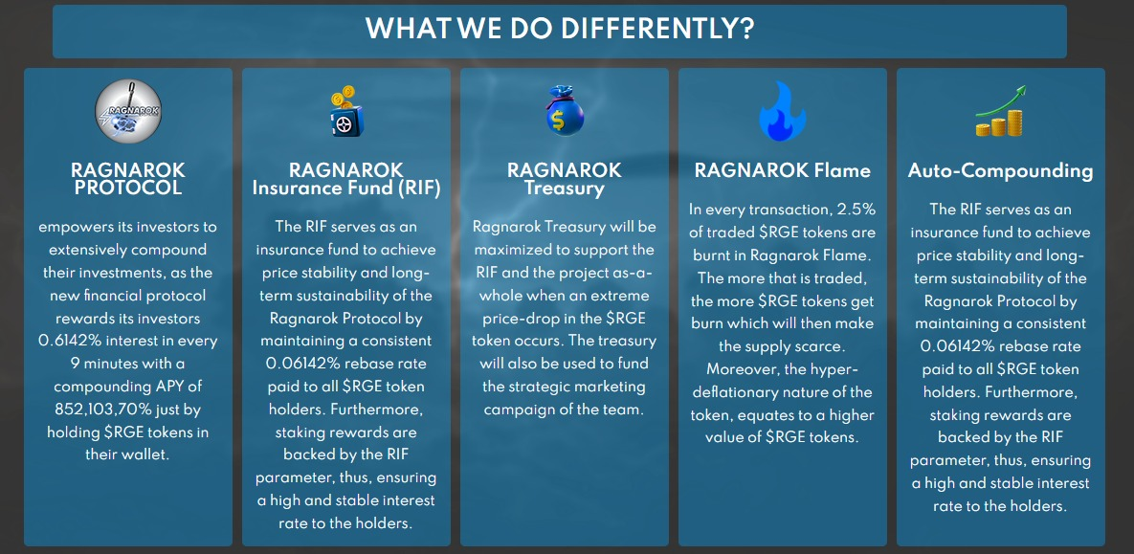

**Ragnarok Insurance Fund (RIF)**Ragnarok Insurance Fund

* **RIF** is the acronym for the Ragnarok Insurance Fund which is a separate wallet in Ragnarok’s **SAP** system. The RIF uses an algorithm that backs the Rebase Rewards and is supported by a portion of the buy and sell trading fees that accrue in the RIF wallet.
* In simple terms, the staking rewards (rebase rewards) which are distributed every 9 minutes at a rate of  **0.06142%** are backed by the RIF parameter, thus ensuring a high and stable interest rate to $RGE token holders.
* 5% of all trading fees are stored in the Ragnarok Insurance Fundwhich helps sustain and back the staking rewards provided by the positive rebase.

**RIF Keeps holders safe by:**

* Avoiding flash crash through price stability
* Achieving long term sustainability and future growth of the Ragnarok Protocol
* Greatly reducing downside risk





**Ragnarok Treasury**

* Ragnarok Treasury plays a very important role in RagnaroK’s SAP protocol. It provides three extremely critical functions for the growth and sustainability of $RGE.
* Ragnarok Treasury functions as additional financial support for the RIF. This additional support can become important in the event of an extreme price drop of the $RGEtoken or unforeseen black-swan event. It helps to establish a floor value for the $RGE token.
* Ragnarok Treasury may also be used to fund new $RGE products, services, and projects that will expand and provide more value to the Ragnarok community aswell as providing funding for marketing.

#### 



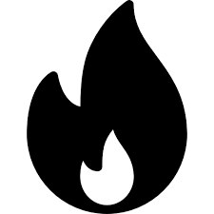

#### **RAGNAROK Flame**

* **2.5%** of all $RGE traded are burnt in Ragnarok Flame. The more that is traded, the more get put into the fire causing the fire pit to grow in size, larger and larger through self fulfilling Auto-Compounding, reducing the circulating supply and keeping the Ragnarok Protocol stable.
* The other benefit to an everlasting burn of circulating supply is that due to the deflationary nature of it, equates to a higher value of each $RGE token, therefore increasing the individual value.

#### 



**$RGE Auto-Liquidity Engine (SALE)  
  
Market Liquidity is of utmost importance and plays a vital role in allowing the buy & sell of $RGE tokens on PancakeSwap.**

* In layman's terms, think of Liquidity as a big pool of money that is split 50/50 between $RGE tokens VS $BNB tokens. There is a conversion ratio that is set to the amount of $RGE you can get with BNB, for example: 1 BNB = 24.66 $RGE.
* When somebody buys $RGE, the price per $RGE will go up and the ratio above will also change at the same time to account for this. The same goes in the opposite direction for sells.
* Liquidity allows for anybody to buy & sell their RGE/BNB at anytime, however the less money/liquidity there is in the pool, the worse price you get so what our Ragnarok Auto-Liquidity Engine (SALE) does, is add more liquidity to that pool by itself and therefore solving that issue.

**Here is how the RGE Auto-Liquidity Engine (SALE) works:**

* Every 48 hours our RGE Auto-Liquidity Engine (SALE) will inject automatic liquidity into the market. On each buy or sell order there is a **4% tax fee** that automatically gets stored into an Auto-LP wallet and built into our protocol's smart contract is the mechanism which smartly takes the 50% of the amount of RGE stored in the wallet, and will **automatically** buy BNB at the current market price.
* The remaining 50% of RGE in the Auto-LP wallet will be used for the RGE side of liquidity, therefore giving equal an 50/50 weighting of RGE/BNB which will then be **automatically** added as new, additional liquidity into the market pair and raising the amount of liquidity in the pool.
* The SALE will do this **every 48 hours** by adding more and more liquidity to the pool which will allow $RGE token holders to easily sell their tokens at anytime with little to no market slippage. It will also aid in **maintaining protocol stability.**

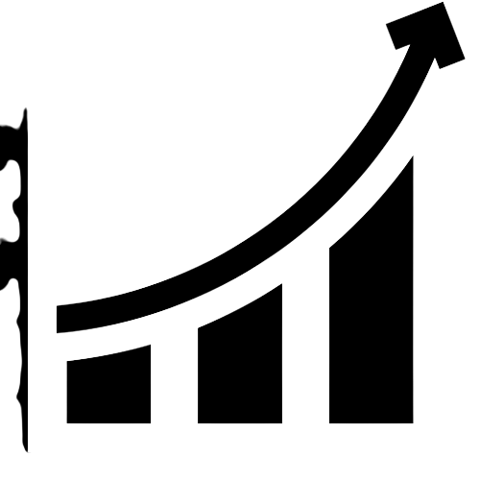

**Fixed APY**

Annual Percentage Yield

* APY stands for Annual Percentage Yield. This measures the real rate of return on your principal amount by taking into account the effect of compounding interest. In the case of RGE, your $RGE tokens represent your principal, and the compound interest is added periodically on every Rebase event (Every 9 minutes), otherwise known as an 'Epoch'.
* Your new principal amount is your then current $RGE token amount, plus your new rebase token amount. This total amount is what gets calculated for your next rebase rewards.
* The Power of Compound Interest - It is important to note that your balance will grow not linearly but exponentially over time. Taking a compound interest of 0.6142%% / 9 minutes:

### **https://github.com/AuditRateTech/Smart-Contract-Audits/blob/main/Ragnarok_Protocol_0xF0140F515FDB68e9f0c40672Eb56e8A14F336Ea7.pdf**

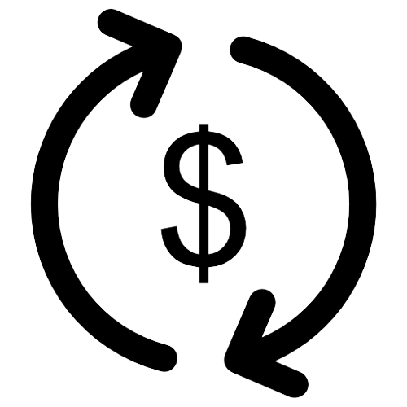

**How the APY is Calculated**

**Calculating APY  
  
Simple Interest Equation (Principal + Interest)**

A = P(1 + rt)

Where:

* A = Total Accrued Amount (principal + interest)
* P = Principal Amount
* I = Interest Amount
* r = Rate of Interest per year in decimal; r = R/100
* R = Rate of Interest per year as a percent; R = r * 100
* t = Time Period involved in months or years

From the base formula, A = P(1 + rt) derived from A = P + I and since I = Prt then A = P + I becomes A = P + Prt which can be rewritten as A = P(1 + rt)

Note that rate r and time t should be in the same time units such as months or years. Time conversions that are based on day count of 365 days/year have 30.4167 days/month and 91.2501 days/quarter. 360 days/year have 30 days/month and 90 days/quarter.

## **Simple Interest Formulas and Calculations:**

A = the Final Investment Value, using the simple interest formula: A = P(1 + rt) where P is the Principal amount of money to be invested at an Interest Rate R% per period for t Number of Time Periods. Where r is in decimal form; r=R/100; r and t are in the same units of time.

The accrued amount of an investment is the original principal P plus the accumulated simple interest, I = Prt, therefore we have:

A = P + I = P + (Prt), and finally **A = P(1 + rt)**

* Calculate Total Amount Accrued (Principal + Interest), solve for A
  + A = P(1 + rt)
* Calculate Principal Amount, solve for P
  + P = A / (1 + rt)
* Calculate rate of interest in decimal, solve for r
  + r = (1/t)(A/P - 1)
* Calculate rate of interest in percent
  + R = r * 100
* Calculate time, solve for t
  + t = (1/r)(A/P - 1)

**P = (Principle + Interest) = $1,000**

**A = (Total Accrued Amount) = $8,521,0,37.12**



**Long term Interest Cycle (LIC)**

* In order to maintain sustainability and future growth, we have introduced a Long term Interest Cycle (LIC) component which will award $RGE token holders with continued compound interest in perpetuity.
* Each Interest Cycle is 9 minutes in length and is referred to as an **EPOCH**.
* There are 35,040 EPOCH's in 1 year.
* **EPOCH 1 - 35,040:** 0.02355% every EPOCH **(First 12 Months)**
* **EPOCH 35,041 - 52,560:** 0.00211% every EPOCH **(Next 6 months)**
* **EPOCH 52,561 - 245,280:** 0.00014% every EPOCH **(Next 6.5 Years)**
* **EPOCH 245,281:** 0.00002% every EPOCH

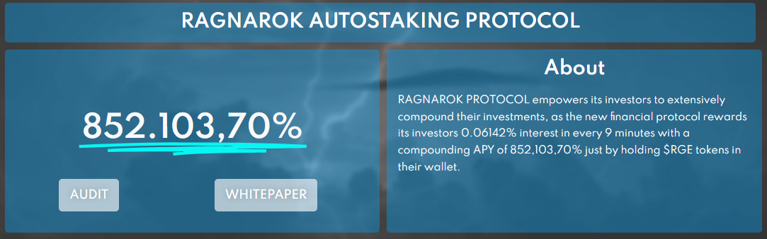

**RGE Token**

**$RGE Token**

$RGE is a Bep20 token which rewards its holders with automatic passive interest payments every 9 minutes over the lifespan of 13.5 years until the maximum supply of 443,884.603 $RGE tokens has been reached.

​

**Is RGE just another Titano Fork?**

* Our entire protocol's smart contract wa.s written and developed from scratch from our own competent group of developers. It does not contain any resemblance to Titano's code or operation as RGE works on a completely new set of mechanics which allows for complete protocol sustainability.
* We also have several proprietary mechanisms in place that we have created ourselves which offers many improvements over our competition such as; our Ragnarok Auto-Liquidity Engine (SALE), the Ragnarok Insurance Fund (RIF), our Long term Interest Cycle (LIC), aswell as safeguards in place which secure against malicious hack attempts.
* Ragnarok’s tokenomics are also completely unique with our Auto-Burn Ragnarok Flame structure, minimal starting supply and lower 9 minute Epoch's for a much more linear APY progression of attainability.

**https://github.com/AuditRateTech/Smart-Contract-Audits/blob/main/Ragnarok_Protocol_0xF0140F515FDB68e9f0c40672Eb56e8A14F336Ea7.pdf**

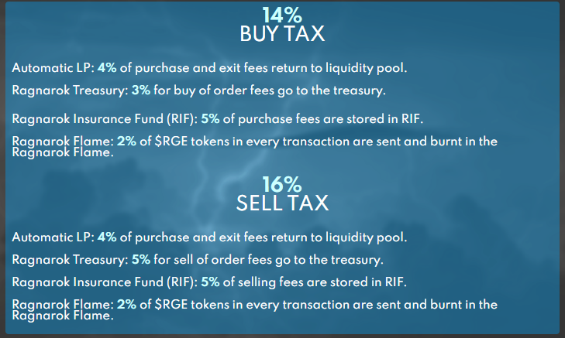

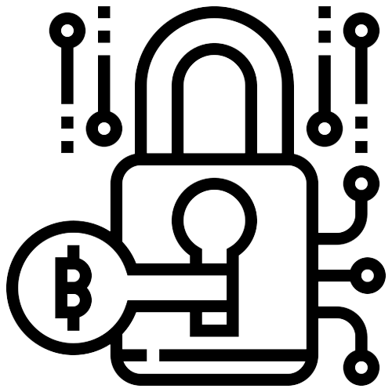

**RAGNAROK Buy and Sell Fees**Market Fees

**RGE buy and sell fees are an important component of the SAP**.

* They provide capital for performing critical functions to the protocol.
* Other protocols utilize selling bonds to support the same functions as RGE fees, but we believe that approach is riskier because if bonds are not purchased, the token can lose its support and spiral downward in price as we have seen with several of these bond based protocols.
* Selling bonds also costs token holders. It reduces the amount of APY that can be offered and eliminates the ability to offer a stable APY.

The amount of the fees (**14% for buys** and **16% for sells**) allows Safuu to provide $RGE holders with the stable high yield of **852,103.70%**  annually.

**Click here** to see the breakdown of fees and where they go.

**https://github.com/AuditRateTech/Smart-Contract-Audits/blob/main/Ragnarok_Protocol_0xF0140F515FDB68e9f0c40672Eb56e8A14F336Ea7.pdf**



**Trading Fees Explained**

​

**Buy Trading Fees:**

* 4 % - LP
* 5 % - RIF
* 3 % - Ragnarok Treasury
* 2 % - Ragnarok Flame

**​**

**Sell Trading Fees:**

* 4 % - LP
* 5 % - RIF
* 5 % - Ragnarok Treasury
* 2 % - Ragnarok Flame

​

**Placement:**

* **LP -** Trading fees goes to backing the liquidity of the BNB/RGE pair on PancakeSwap ensuring an ever-increasing collateral value of $RGE.
* **RIF -** Trading fees are stored in the RGE Insurance Fund which helps sustain and back the staking rewards provided by the positive rebase.
* **Ragnarok Treasury -** Trading fees go directly to the treasury which supports the RIF and provides a marketing budget for RGE and funds new product development.
* **Ragnarok Flame -** 2.5% of all $RGE traded are burnt in the Ragnarok Flame. The more that is traded, the more get put into the fire causing the Ragnarok Flame to grow in size, larger and larger through self fulfilling auto-compounding which in return acts to reduce the circulating supply of $RGE and keeping the Ragnarok protocol stable.



**Roadmap**Priority Checklist

**YEAR 2022**

* Website Development
* Whitepaper Documentation
* Build Phase - Smart Contract
* Build Phase - dApp V1 Dashboard
* Deployment Phase - Smart Contract - Testnet
* Solidity Finance Audit
* Deployment Phase - Smart Contract Deployment - Mainnet
* Deployment Phase - dApp V1 Dashboard
* Initiate and Promote Discord Community
* PR Marketing
* Bounty Campaign
* Pre-Launch Marketing
* Fair Launch on PinkSale
* PinkLock Liquidity Locked 13.5 years
* Twitter Marketing Campaign
* YouTube Marketing Campaign
* CoinMarketCap Listing
* Certik Application
* Certik Listing
* Certik Audit
* Airdrop Campaign
* CoinGecko Listing
* SEO
* 5,000 Token Holders
* 10,000 Token Holders
* 15,000 Token Holders
* 20,000 Token Holders
* 50,000 Token Holders
* 100,000 Token Holders
* 500,000 Token Holders
* 10 Million Market Cap
* 25 Million Market Cap
* 50 Million Market Cap
* 100 Million Market Cap
* 200 Million Market Cap
* 300 Million Market Cap
* 400 Million Market Cap
* 500 Million Market Cap
* 1 Billion Market Cap
* Build Phase - dApp v2 Dashboard
* Deployment Phase - dApp v2 Dashboard
* Cross-Chain Integration
* Partnerships
* Server Migration to AWS
* Web Store Rollout
* Merchandising
* Acquisition of RGE Racing Team (RRT)
* SRT Website, PR and Marketing Campaign
* SRT Events, Merchandising and Community Promotions
* Development Mobile Application iOS and Android
* Launch Alpha Version Mobile Application iOS and Android

**YEAR 2023**

* Smart Contract v2 Build Phase
* Smart Contract v2 Deployment
* Full Migration to v2
* 10 Billion Market Cap
* 50 Billion Market Cap
* 1 Million Token Holders
* SRT Expansion into Formula 1
* SRT Sponsored Events Worldwide

**YEAR 2024**

* Expansion into RGE Blockchain - A Complete DeFi Multi-Chain Solution
* Become a Leading Top 10 MarketCap Cryptocurrency
* 100 Billion Market Cap

**YEAR 2025**

* Overtake Ethereum in MarketCap

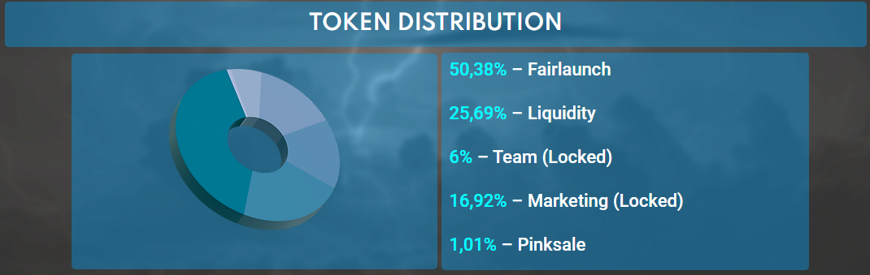

**$RGE Tokenomics:**

**Initial Supply - 443,884.603 $RGE**

**Available to Purchase on PinkSale   
  
Pre-Launch - 196,000 $RGE**

**Tokens for Liquidity -** 99,960 $RGE

**Token Breakdown -** 99,960 will be used for PancakeSwap to match 51% liquidity.

**NO TEAM TOKENS -** The RGE Team will **NOT** hold any tokens. The only tokens owned by the Ragnarok Treasury will be collected via accumulating trading fees. We are committed to the longevity of the project and thus the $RGE team cannot dump on you.

**NO EXTRA MINT OR HIDDEN TOKENS -** The $RGE smart contract has **NO** ability to mint extra tokens nor can the supply be manually increased or used in an artificial way to change the initial supply by awarding ourselves free tokens. The initial supply is 443,884.603 $RGE tokens only (please see the breakdown above).

**NO RUG PULL -** Liquidity will be **locked for 401 days** via trusted Unicrypt.Network which cannot be touched or released early. (This means that you as a token holder will **ALWAYS** have the freedom to buy/sell whenever you like without restrictions or complications - your tokens that you buy are yours and remain in your wallet always and are never 'locked').





# **The Ragnarok Protocol Team**

## Our team consists of intensely driven and crypto-enthusiast individuals with solid experience in DeFi. The team has undergone KYC certification with Pinksale and plans to publicly dox in a certain milestone as we value our holders trust the most.

Access our social network

Site:  
<https://www.ragnarok.finance/>  
  
Twitter:  
<https://twitter.com/rgeprotocol?s=21>  
  
Telegran:  
https://t.me/ragnarokprotocol